How to pull “top tweets” and a summary of tweeters using TAGS
- This summary is based on the following data extracted at 8PM on 4 May 2018.
- Go to TAGS website: https://tags.hawksey.info/get-tags/ and follow set up instructions.
- Select your search term and period to search (up to a week into the past) into TAGS “ReadmeSettings” sheet.
- Insert columns for number of like and retweets in the “archive” sheet (call them “favorite_count” and “retweet_count” – in the example sheet I have inserted them to columns F and G).
- Once you have the data extracted, download as an Excel spreadsheet. Do not overwrite other columns.
- Add three columns to the archive sheet – “Tweets”; “Likes + retweets”; “Day” in the example spreadsheet. Copy the formulae across from the example spreadsheet, right down to the bottom of your sheet. These columns identify tweets rather than retweets, record the sum of likes and retweets for these tweets, and then takes the date from the “time” column.
- Select all the data in the archive sheet and sort as required using the new columns, starting with “tweet” column and then ordering, for example, by popularity of tweets (“likes + retweets” in descending order). In this example I have used “Day” as well (eg if wanting to achieve a balance in number of tweets for each day of a conference or campaign):
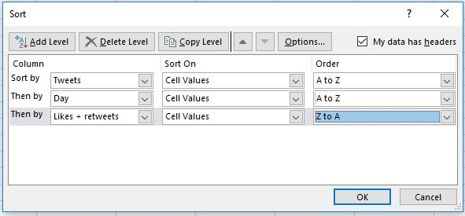
- Add a column called “Selected”. Choose the tweets you want to select (eg those tweets with at least 15 likes or retweets combined). Select all the data in the archive sheet then sort the sheet by “selected” and “time” columns to order these tweets chronologically:
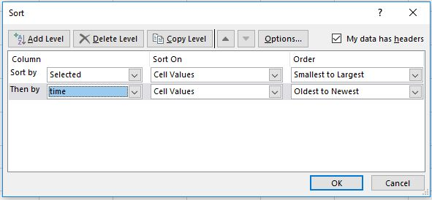
- Replace “statuses” in “status_url” column to “status” otherwise the URLs won’t work properly in Wakelet:
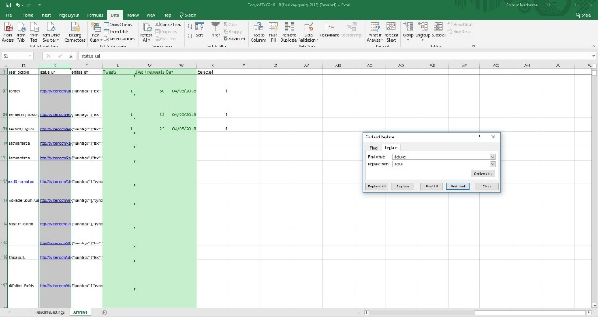 |  | 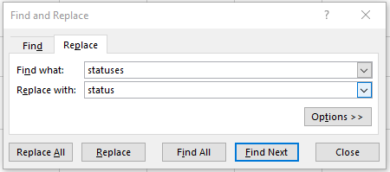

- Copy and paste the “status_url” for individual tweets into a Wakelet summary: https://wakelet.com/ (I usually start with the last tweet and work upwards).
- If you want to quantify the number of tweets, retweets and likes for the period in question add pivot charts as shown in the example spreadsheet (“workings” sheet).
i. Insert a table of tweets | ii. Copy table i and adapt to produce sum of retweets | iii. Copy table i and adapt to record number of followers
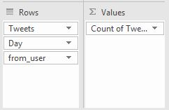 | 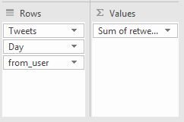 | 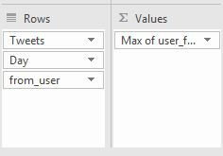
- Order the “retweets” table (ii) by number of retweets, and the “tweets” and “followers” (i and iii) by tweeter (you’re going to use VLOOKUP command in Excel and this needs alphabetical order).
- Use these tables to identify number of tweets, tweeters and retweets (some are displayed automatically, others need a counting or adding using Excel commands). You can then work out summary statistics and top 20 tweeters.
Graham Mackenzie, Public Health Doctor 5 May 2018

@gmacscotland on Twitter

You can read more about methods in this blog.

