#AllergyHM17
Allergy Awareness Week , 13th -17th Nov '17
Hairmyres Hospital , NHS Lanarkshire
Fran Kerr, Antimicrobial Pharmacist, NHS Lanarkshire
The aim of Hairmyres Hospital Allergy Awareness Week (#AllergyHM17) is to improve assessment and documentation of patient medication allergies to reduce harm associated with the administration of medication to which the patient is allergic.
More reliable assessment and documentation of allergy, including the detail of any previous reactions, will also allow future engagement with the national SAPG (Scottish Antimicrobial Prescribing Group) strategy to remove mislabelled penicillin allergy status. When patients are treated with alternatives to penicillin, because of mislabelled allergy, they have a more prolonged hospital stay and are at greater risk of developing resistant infections.
Allergy Awareness week is supported by medical, nursing and pharmacy management and incorporates ward based activities plus social media (Twitter)
Ward activities include posters, quizzes including a novel 'hands on' antibiotics categories quiz, audit and daily staff safety briefs. Safety briefs are led by different staff groups each day including medical, nursing and pharmacy on a different theme each day. Daily themes include documentation, administration checks, high risk moments and patient empowerment
Incentives including a ward hamper, voucher and the 'twittercup' provide further motivation for wards to participate and generates some friendly competition.
The format of 'Awareness Week' has been tested previously (eg see this summary of the Monkland Hospital campaign) and has been shown to encourage ward based learning and teamwork and promote joy at work.
Other local awareness weeks include:
#MKallergyawareness17, #MKDPS17, #MKMAW17

For more information please contact:
frances.kerr@lanarkshire.scot.nhs.uk
or on Twitter @Frankerr1F
Daily 'gold star 'medals
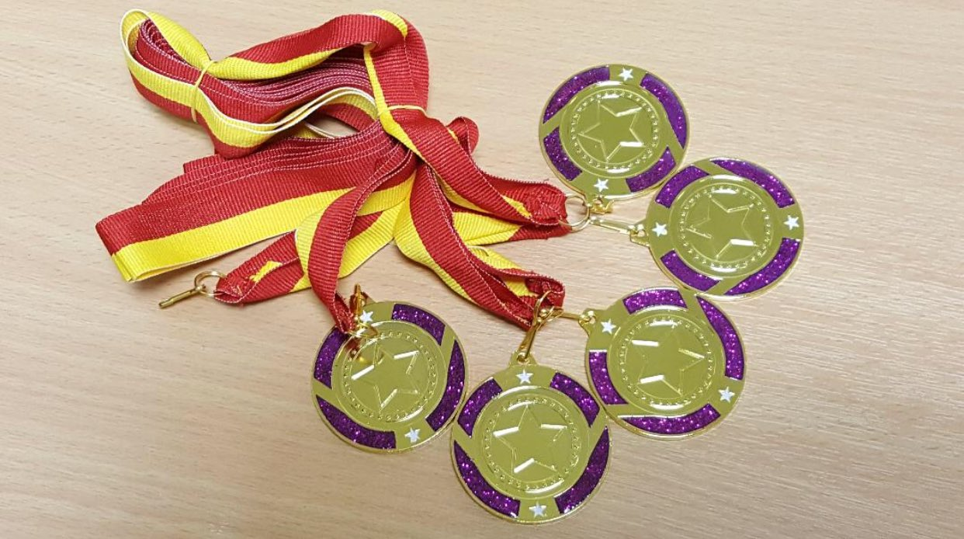
Activities for the week including daily safety brief topics
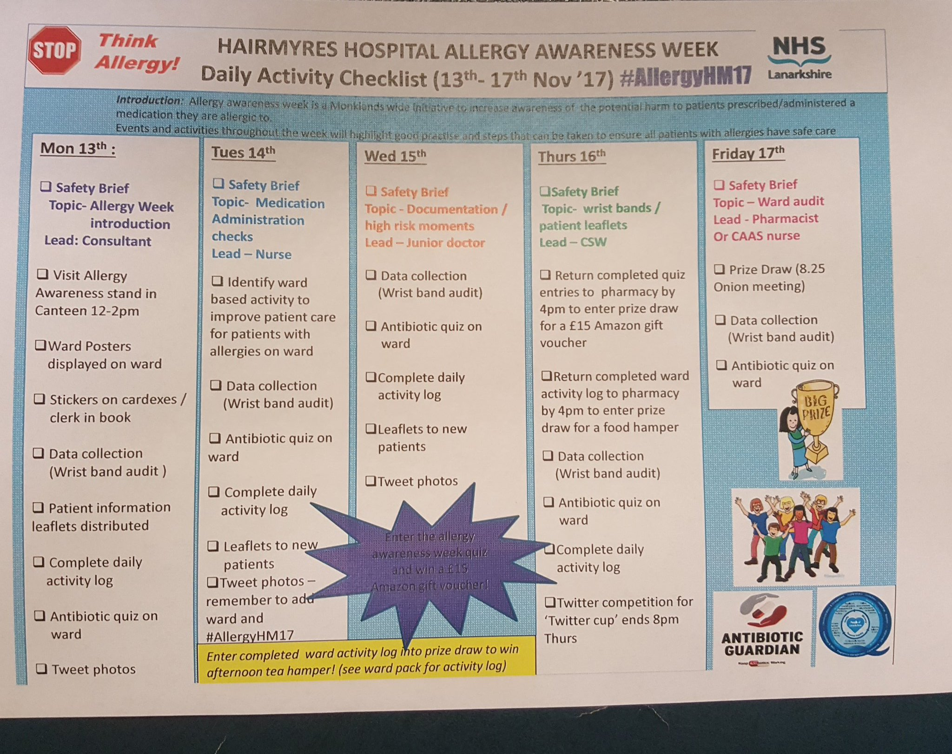
Twitter Cup
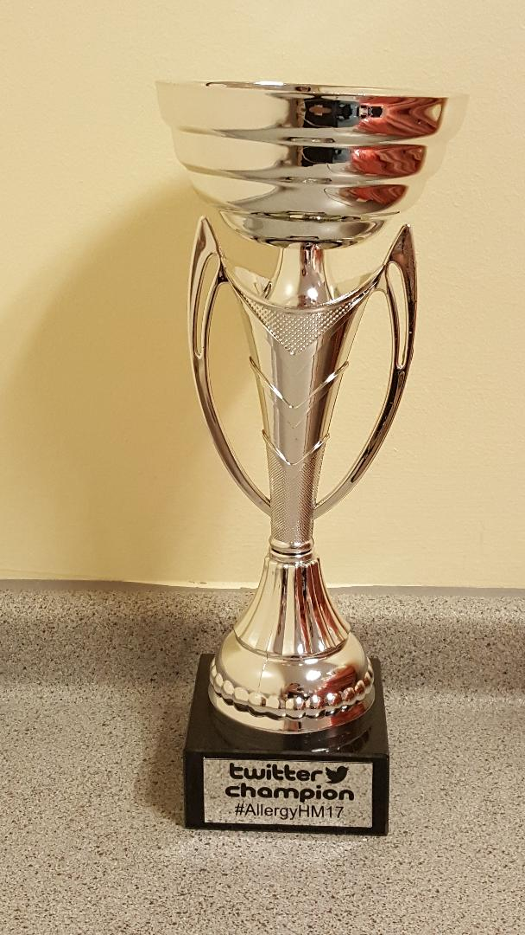
Stop think Allergy Pens
